Introduction
With InstallAware, there is never a need to manually call msiexec.exe. Available only with InstallAware, the (Un) Install MSI Setup plug-in allows you to achieve better, more integrated results when working with MSI packages. (Un) Install MSI Setup is fully integrated into the InstallAware IDE and allows you to install, re-install and uninstall MSI packages, all within your InstallAware MSIcode.
(Un) Install MSI Setup
While (Un) Install MSI Setup behaves exactly the same as msiexec.exe, it also allows you to capture, display, and catch errors of your the native MSI installation progress within the InstallAware installation. Think of (Un) Install MSI Setup as a shell to Windows Installer. Essentially, this means that the end-user would be unaware that any third-party setup is running, which is a great benefit to user experience. The progress of your MSI installation will automatically be displayed if a non-modal progress dialog is displayed.
Furthermore, (Un) Install MSI Setup also allows to invisibly pass Windows Installer command line parameters. (Un) Install MSI Setup directly calls MSI API’s, therefore any parameter that is passed to the plug-in does not propagate outside of the InstallAware environment and thus is not visible to your users. (Un) Install MSI Setup also allows you to save a log file, get the last error, and get the result of the MSI installation process.
Example
In this example, we will create a setup that installs SQL Management Studio Express (available here). with the use of (Un) Install MSI Setup.
Lets create a project using the Basic Setup template.
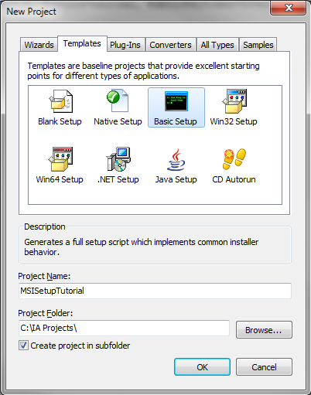

Now, lets go to the MSIcode tab and add our MSI file to the support files. Right-click Support Files and then press Add Files to Project. The support files are available to our installer during setup and used as resources.
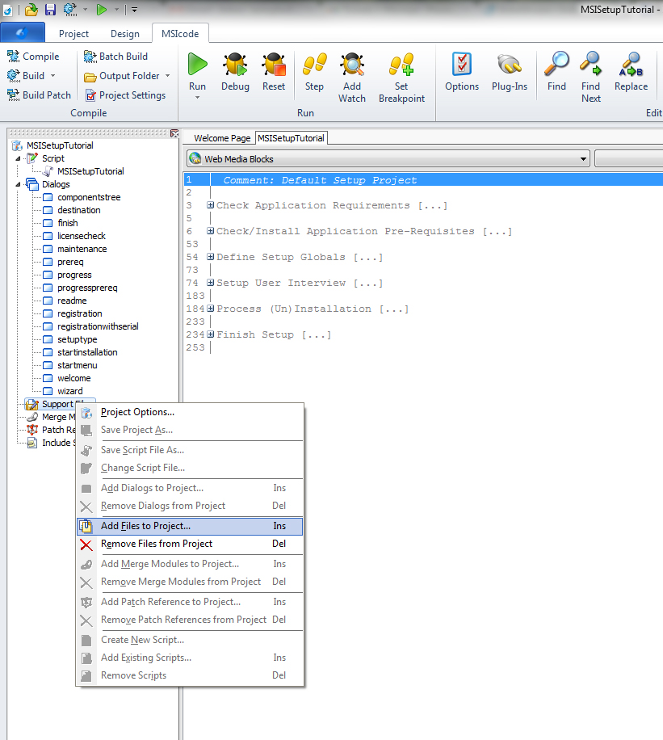
Now, we would like to add the code that installs our MSI. Lets go to the Perform First Time or Maintenance Installation region in our MSIcode. InstallAware created the structure of the installation for us, so all we have to do is add the (Un)Install MSI Setup command right before the Apply Install command. Lets select the Apply Install line and start typing (Un).. till InstallAware auto-completes our entry to (Un)Install MSI Setup, and then we will press ENTER. We wish to install our MSI package so lets click on “Install” and let InstallAware auto-generate the right parameters to perform an installation.
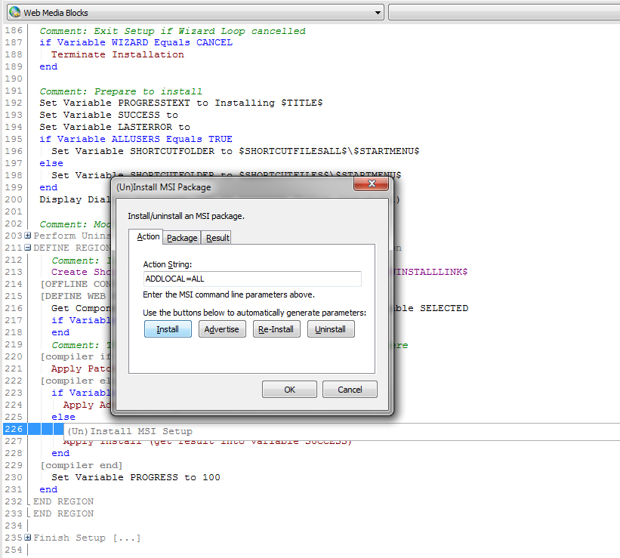Please note that additional parameters can be added to the Action String. Essentially, the Action String is a collection of Windows Installer property definitions in the form of PROPERTY=VALUE. A list of these properties can be found here. For example, in order to perform an MSI installation with a transform file (MST), you could specify the parameter “TRANSFORMS=transform.mst” (the TRANFORMS parameters is a list of transform files. More than one such files could be used in the form of “TRANFORMS=file1.mst;file2.mst”). The filename passed to the TRANSFORMS property could either be a path relative to the MSI you are installing, or an absolute path. Whenever passing a value that contains spaces, quotation marks should be used. For example, if we want to specify two transform files, “C:\Folder 1\t1.mst” and “c:\t2.mst”, this would be the way to do it: TRANSFORMS=”C:\Folder 1\t2.msl;C:\t2.mst”.
Similarly, you can apply a patch to an installation by specifying the parameter “PATCH=patch.msp” (keep in mind that in order to apply a patch to an installation you will also need to specify the MSI to which you are applying the patch, either by using the MSI file as a reference or the package’s Guid).

Lets switch over to the Package tab, select Use Package File and input the file name of our MSI package – in this case, $SUPPORTDIR$\ SQLServer2005_SSMSEE.msi.
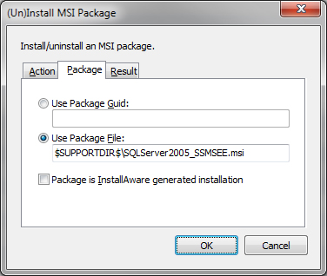

Lets also capture the result of the installation as well as the last error. Go to the Result tab and type in the names of your result and last error variables.
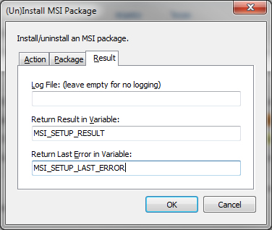
Lets press OK. Now, there is only one problem – we the used both the MSI_SETUP_RESULT and the MSI_SETUP_LAST_ERROR variables but did not declare them before. Remember – variables that are used in plug-in commands must be declared before usage. Lets declare the two variables before using them by adding Set Variable commands.
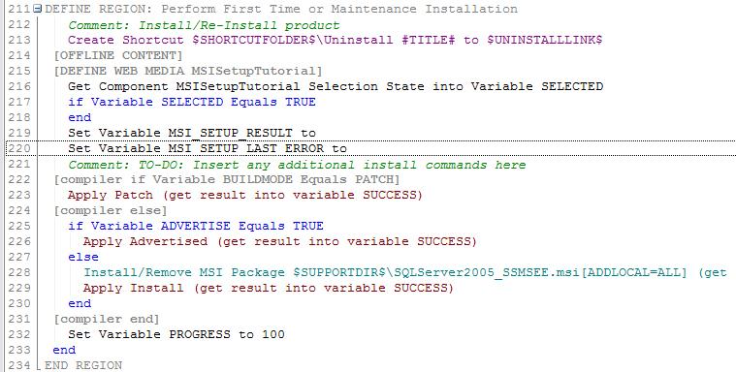
Now, since at line 200 we have a progress dialog displayed non-modally, when our installation will run, the progress dialog will automatically show the progress of our SQL Management Studio Express setup.
After the call to (Un)Install MSI Setup lets also check whether the installation succeeded. Lets add an If command that checks the variable MSI_SETUP_RESULT and compares it to ERROR. Note that the MSI_SETUP_RESULT can have three values: SUCCESS – if the installation succeeded, ERROR – if an error was encountered during the installation, and REBOOT – that indicates that a reboot is required. In case the If command evaluates to TRUE and we indeed had an error during the installation, lets display a message box to the user that explains the error that has occurred (with the use of MSI_SETUP_LAST_ERROR that we declared before) and terminate the installation.
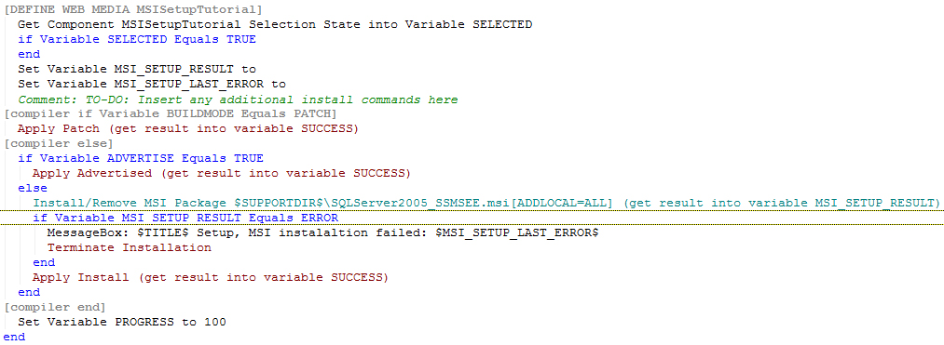

Lets build and run our installer and check to see if it works. Lets run through the wizard and begin the installation. As you can see, the progress dialog displays the progress of the external MSI installation.
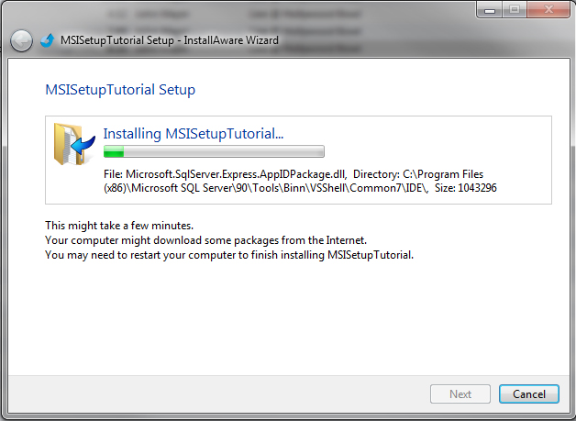

Now, lets make sure that when our program is uninstalled, we uninstall the MSI package that was installed during setup. Lets look at the region Perform Uninstallation. The code checks if the REMOVE variable equals TRUE, or in other words, if the user has selected to uninstall the program. Right after this check, lets uninstall our MSI from before. We will start typing (Un).. and press ENTER once InstallAware auto-completes our input to (Un)Install MSI Setup. In the package tab we could two things. Either do the same as we did when installing the MSI package before and provide the MSI package’s file name, or select Use Package Guid and enter the Guid of the MSI we wish to uninstall. However, even though it is guaranteed to us that all support files will be on the machine both at install time and uninstall time, the best practice to uninstall MSI packages would be to use the package Guid method. In order to find the Guid of our MSI installation package, we will use the free Orca MSI Editor tool available here. Using Orca, we will open our MSI package and look at the tables list on the left-hand side. Lets select the “Property” table, and inside it, the ProductCode property holds the MSI’s product code.
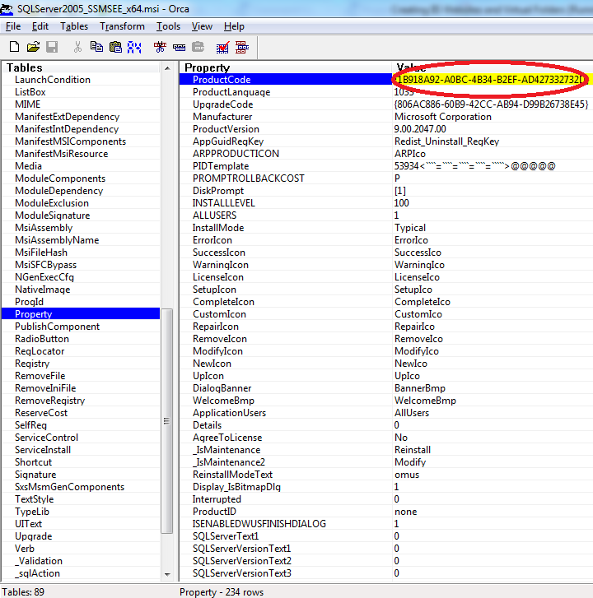
Now lets go back to InstallAware and enter this Guid in the Use Package Guid field. Under the Action tab, lets click on Uninstall in order to let InstallAware auto-generate the parameters for the uninstallion operation. Since we are uninstalling, we do not necessarily have to check what the uninstallation process returned (however it is strongly recommended to do so, and to at least let the user know if a component has not been uninstalled from his system).
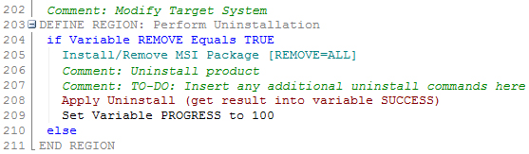
When our program will get uninstalled now, SQL Management Studio Express will also be uninstalled.

Summary
In summary, (Un)Install MSI Setup is an extremely powerful tool, allowing you to install MSI packages within your InstallAware installation seamlessly and consciously.

