On Click of UnInstall in ControlPanel->Programs->Programs and Features, we get the Installaware Uninstall dialog with 3 choices.
Click Cancel on this dialog
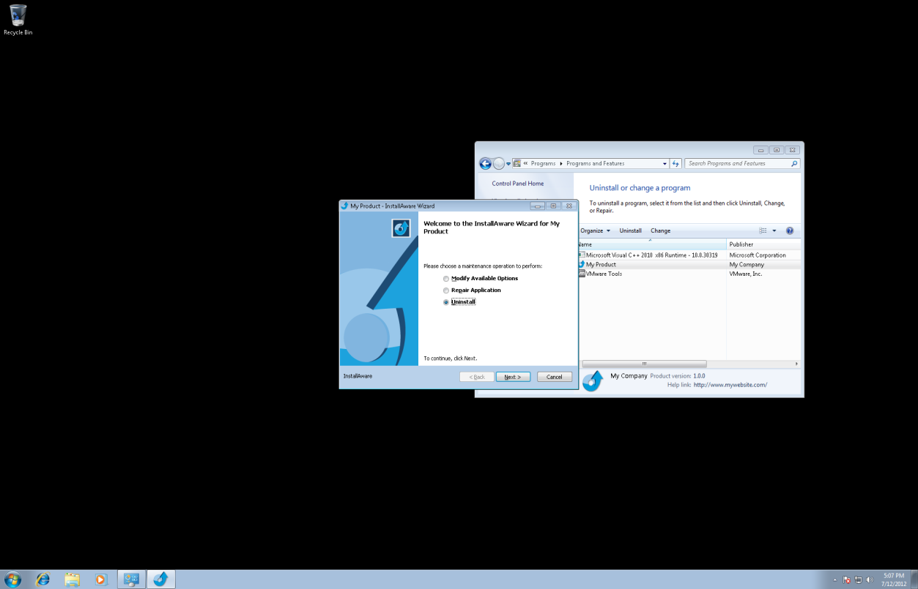
Click Yes to cancel the Uninstallation
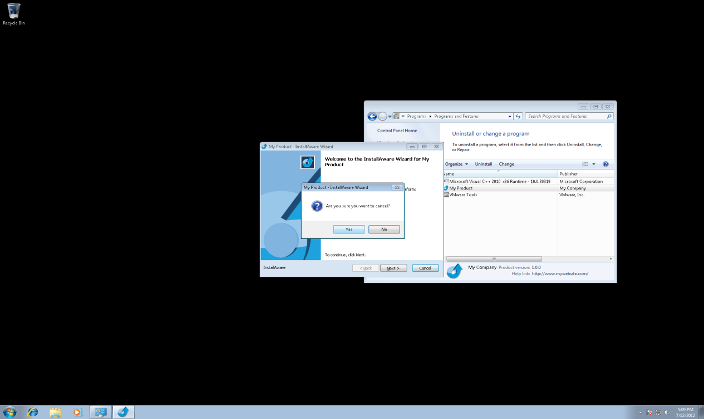

Once again, On Click of UnInstall in ControlPanel->Programs->Programs and Features, we get the InstallAware ApplicationRequirements form.
Click Next
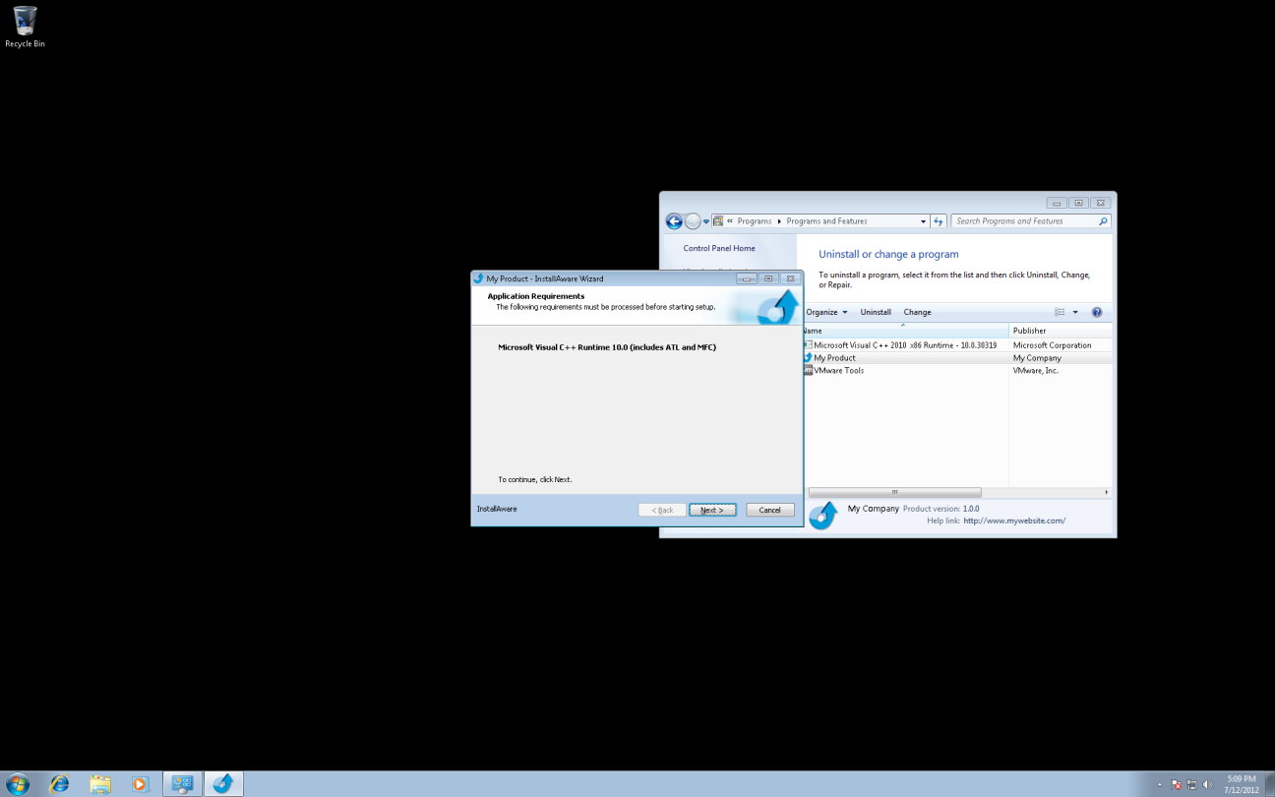
Clicking Next Pops up the Browse folder dialog to locate the setup sources. Now click cancel.
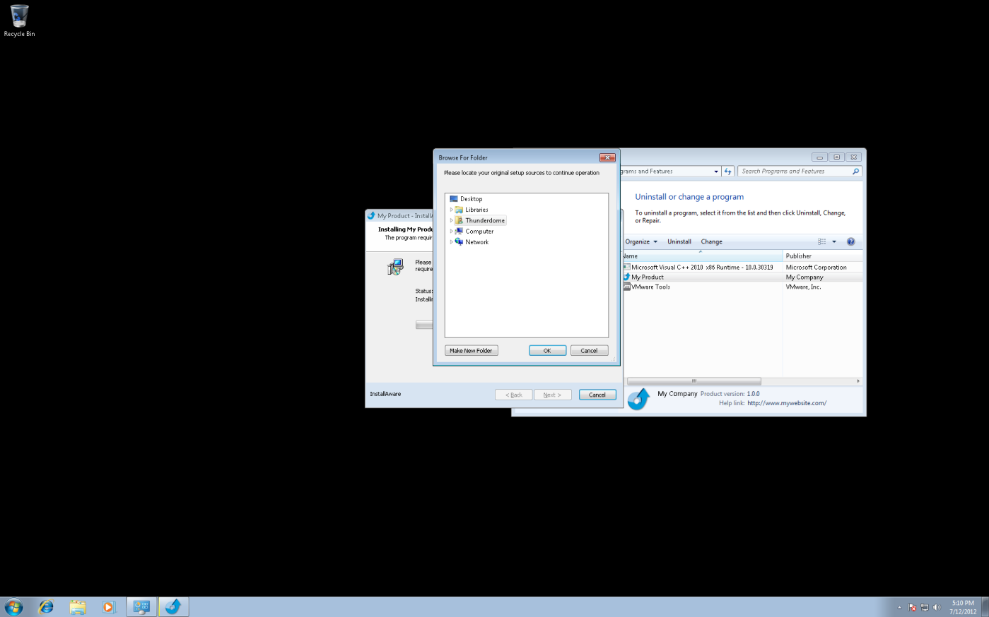
We get the following error.


