Introduction
With InstallAware 10, images can be dynamically loaded onto dialog controls at runtime. This is very useful in case you have a single dialog that is displayed numerous times in different contexts and thus requires its images to be changed at runtime.
Usage
Lets start by creating a new project from the Blank Setup template.
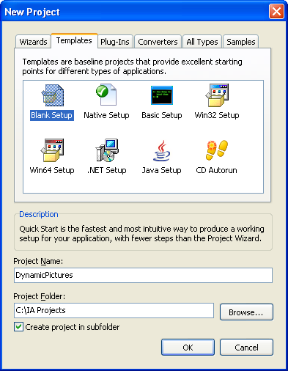
Lets create a new dialog by switching over to the Design tab and clicking on Edit Forms. In this case, I changed the dialog’s height and width to 400 pixels.

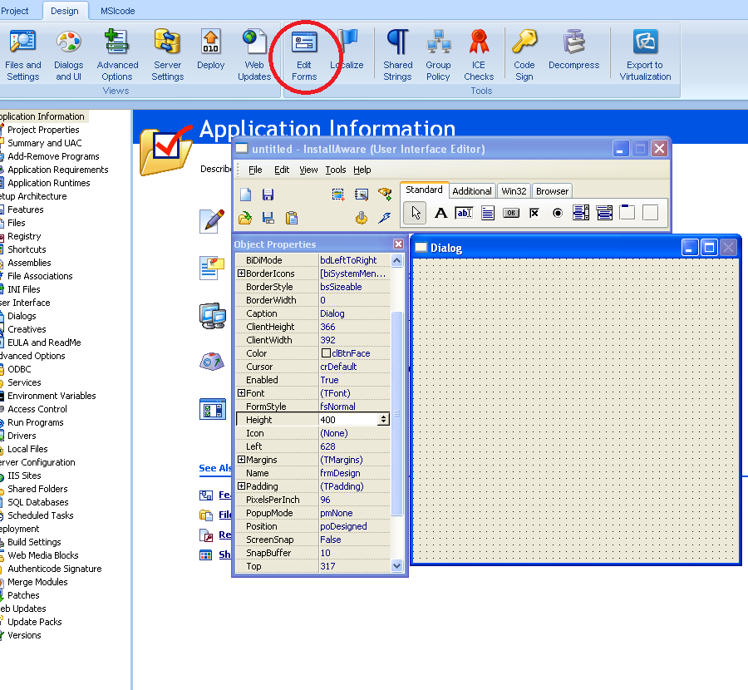Now we will add an Image to our dialog by clicking on Image under the Additional tab and then clicking anywhere in our dialog. Lets change the name of our new Image dialog control to “DIALOG_IMAGE”.
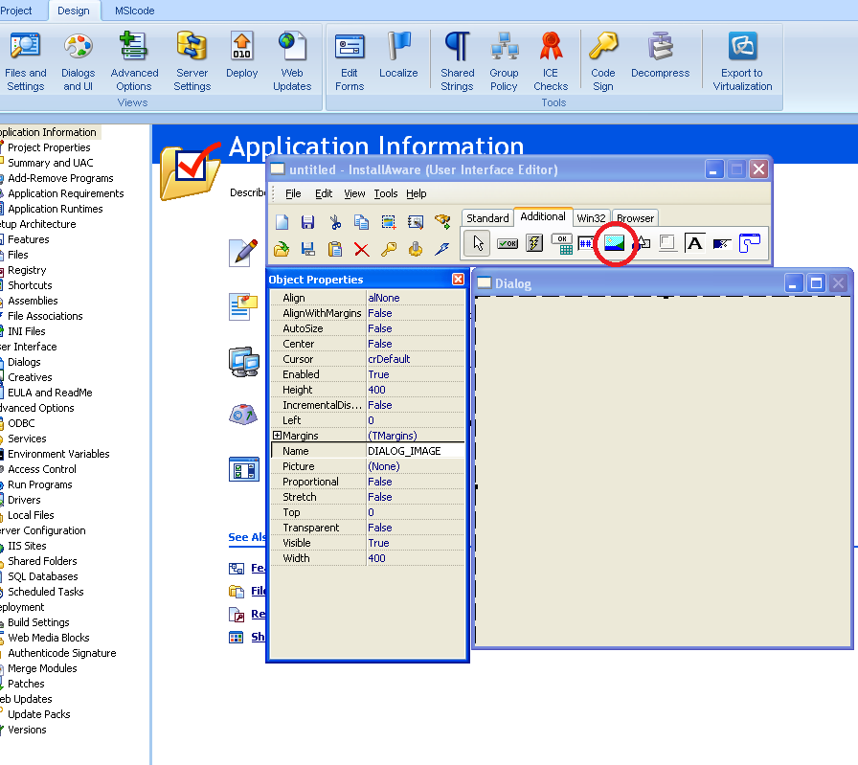
Lets also add a Button control (found under the Standard tab) to our dialog so we could close it (we will name the Button “Close”). Double click the Button and set the Performs Action property to “Return from Dialog”. This will cause our dialog to close when the Close button is pressed.
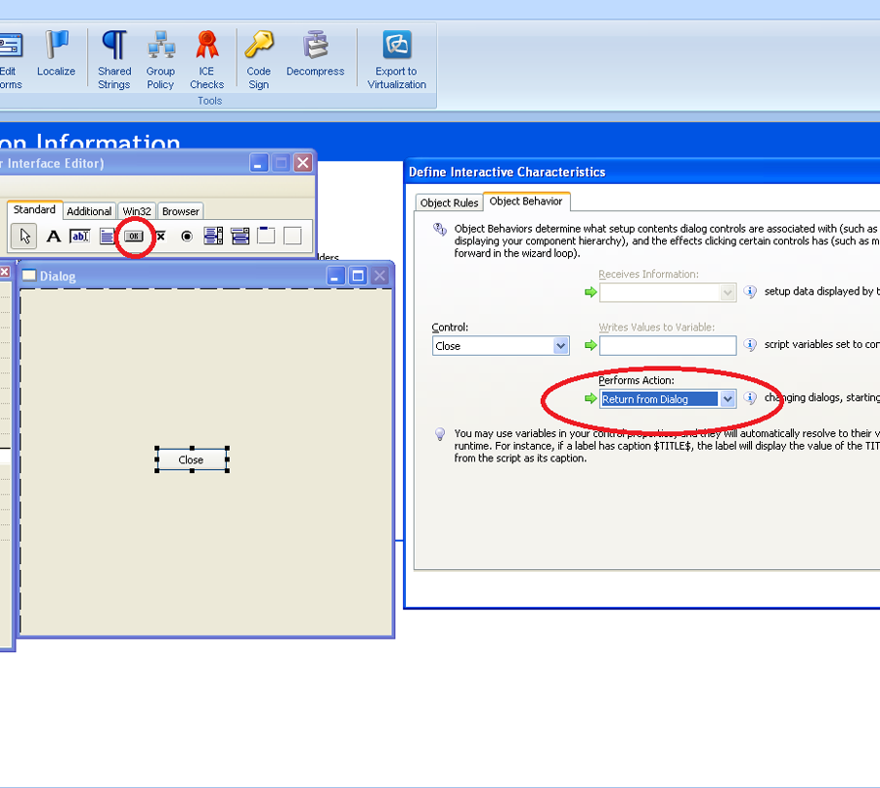
Once we are done with our dialog, lets save it to the disk by clicking File -> Save As in the form editor. Now, lets switch over to the MSIcode tab and right-click the Dialogs menu item on the left hand side. Click on Add Dialogs to Project and select Choose Dialog to Add by File Name. Click Browse, and point InstallAware to the dialog we saved before.
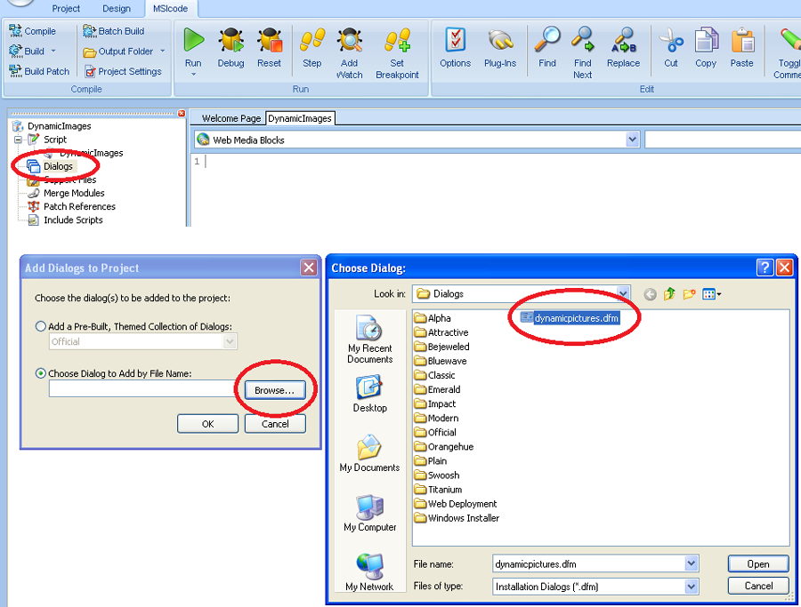
The dialog we previously created is now associated with our project. Lets now actually create the script that shows the dialog and changes its image. In order to change the image that is displayed in the dialog in runtime, we need to define a script variable that has the exact same name as our Image control (in our case, as you remember, “DIALOG_IMAGE”). Set this variable to a full file system path of the image that you wish to load onto the Image control (such as a file in $SUPPORTDIR$, or a file installed/already present on the target system). Please note that if this variable is not set or is not defined, the image that will be displayed is the initial Image that was set under the Image’s “Picture” Property. Lets build and run the project and as we can see, we have three different dialogs with three different background images!
