TEST 1 – Applying permission for LUKE\IUSR_LUKE:
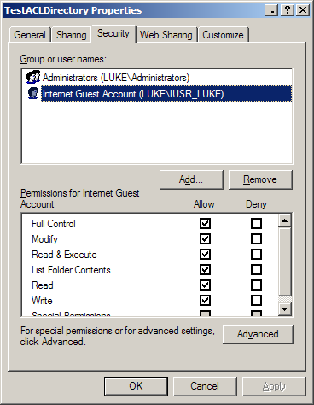

TEST 2 – Applying permission for LUKE\IWAM_LUKE:
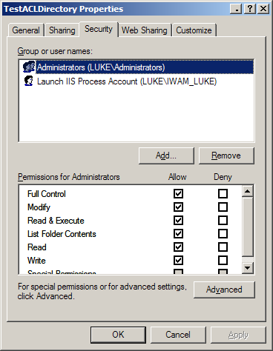
TEST 3 – Applying permission for LUKE\ASPNET:
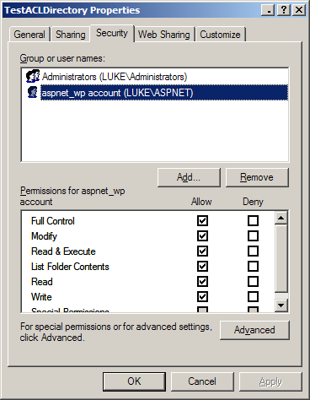

TEST 4 – Applying permission for LUKE\IUSR_LUKE , and LUKE\IWAM_LUKE:
TEST 5 – Applying permission for LUKE\IWAM_LUKE, and LUKE\IUSR_LUKE:
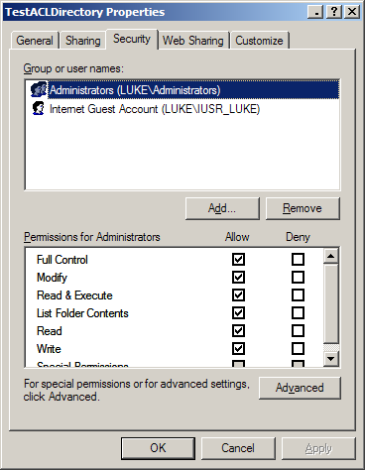

TEST 6 – Applying permission for LUKE\IUSR_LUKE , LUKE\IWAM_LUKE, and LUKE\ASPNET:
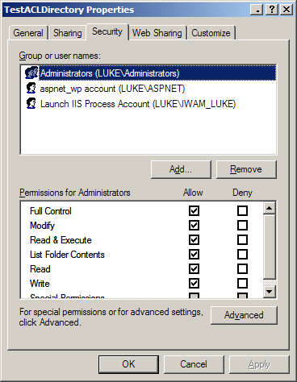
Manually applying permission for LUKE\IUSR_LUKE , LUKE\IWAM_LUKE, and LUKE\ASPNET thru windows explorer (demonstrating that windows allows all three ACEs to exist at one time):
